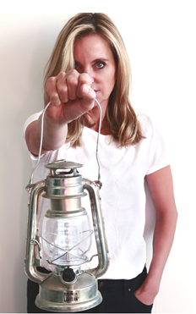
About Rachel Lee Hovnanian

Born in Parkersburg, West Virginia and raised in Houston, Texas, Rachel Lee Hovnanian is a New York-based artist whose multidisciplinary practice explores contemporary notions of narcissism, obsession and intimacy, and society’s alienating addiction to media & technological innovations. She navigates the post-internet world, merging photography, video, sculpture, painting and installation art into surreal environments that challenge viewers to examine and re-evaluate their own cultural values and relationship with digital technology.

She has been described as “a wizard at fingering uncomfortable truths,” by Judith Stein.
Shiva Balagali said, “Hovnanian is one of the more interesting feminist artists working in the contemporary art-world, delving into the important theme of beauty in her work.”
Hovnanian received her BFA from the University of Texas, Austin, and has since exhibited internationally in both solo and group exhibitions in the United States, Asia, Europe and the Middle East. Her recent solo exhibitions have been held at Leila Heller Gallery, New York; Pechersky Gallery, Moscow; Joyce Gallery, Beijing; and Foundation Pons, Barcelona.

In addition, Hovnanian has been shown in group exhibitions including at the University of Connecticut, Connecticut; Parasol Unit, London; Des Moines Art Center, Des Moines; Manarat al Saadivat, Abu Dhabi; and Loretta Howard Gallery, New York in an exhibition curated by Beth Rudin DeWoody. Hovnanian’s artwork has been featured in numerous publications such as The New York Times, WWD, Flaunt, Cultured, The Wall Street Journal Europe, Vogue, Interview, Tatler, Food & Wine, ARTnews, Modern Painters, Hyperallergic and BOMB.

Her work is in the collection of the Royal Family of Dubai, Lily Safra, the Mallin Collection, as well as in the corporate collections of AT&T, Dior, Graff Diamonds and TD Bank, MAMM (Moscow’s Multimedia Art Museum) and the 21c Museum Hotel. Her artworks were also part of the Art in Embassies Program.

www.rachelleehovnanian.com | @rachelleehovnanian

