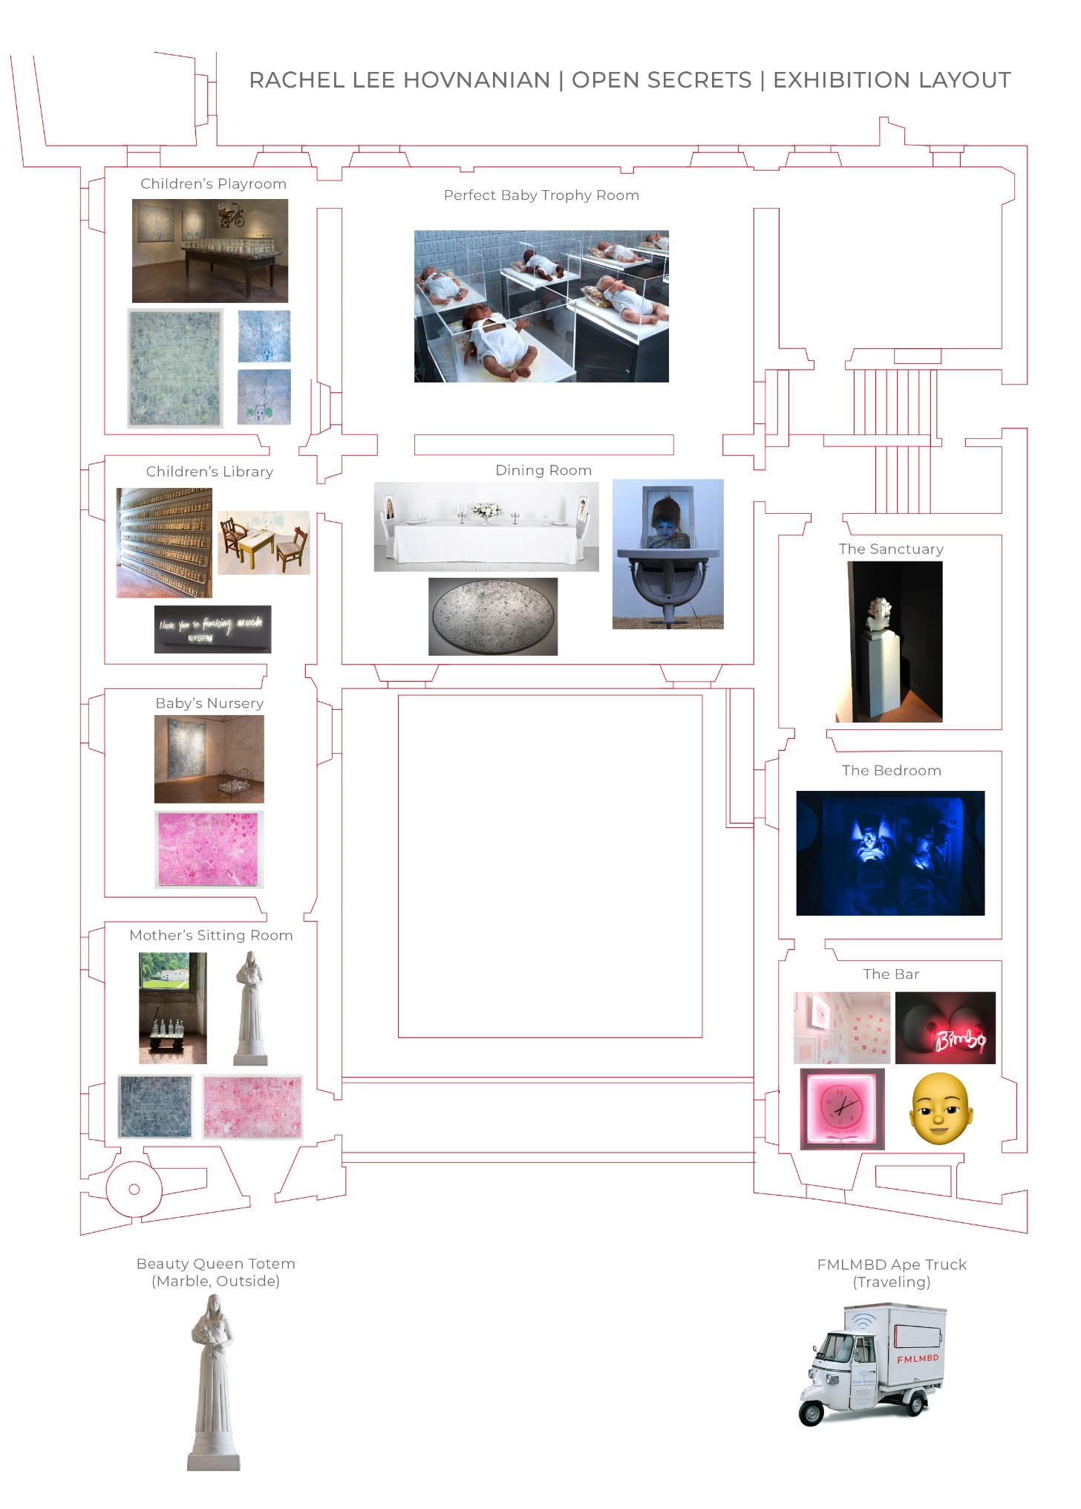

**FMLMBD Ape Truck (Traveling)**

**Beauty Queen Totem (Marble, Outside)**

**The Bar**

**The Bedroom**

**Dining Room**

**The Sanctuary**

**Mother’s Sitting Room**

**Baby’s Nursery**

**Children’s Library**

**Children’s Playroom**

**Perfect Baby Trophy Room**

**RACHEL HOVNANIAN *“OPEN SECRETS”* EXHIBITION AT PALAZZO MEDICEO - ARTWORKS LOCATION**